Sensor locations

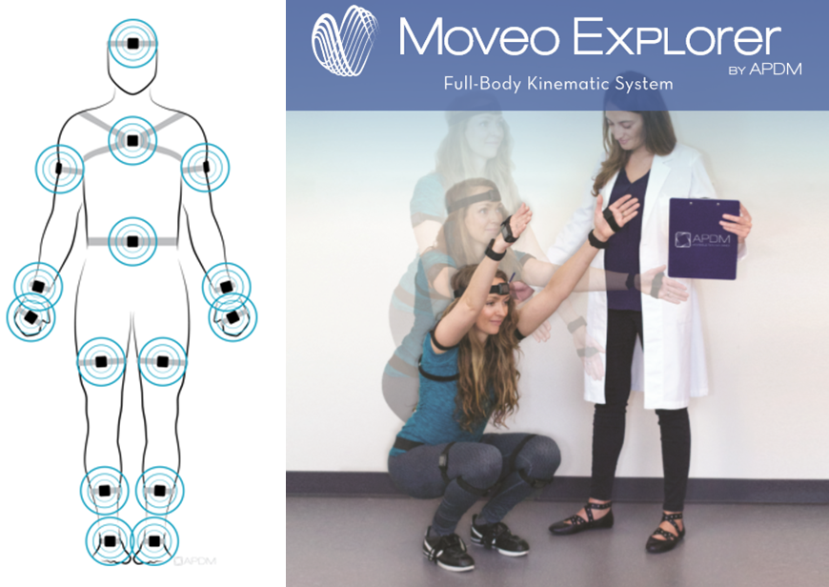

Sensor locations

|  |  |
| --- | --- |
| **Location** | **Description** |
| Foot | Centred on top of the foot |
| Lower leg | Inside the front of the shin on the flat surface of the bone, high enough for the strap to wrap just above the widest part of the calf muscle |
| Upper leg | Side of the thigh, midline between muscular tissue, one hand’s width above the knee |
| Lumbar | Centred on the low back at the base of the spine |
| Sternum | Centred on the flat surface of the chest, just below where the collar bones meet |
| Head | Centred on the front of the forehead |
| Upper arm | Centred on the outside of the arm, just below the shoulder muscle |
| Wrist | On the wrist worn like a watch |
| Hand | On the back of the hand |